Therme Vals
The project uses topologicpy to convert the architectural geometry of Peter Zumthor's Therme Vals into a spatial graph, revealing the hidden thermal sequence and circulation logic of the building as a network of connected spaces
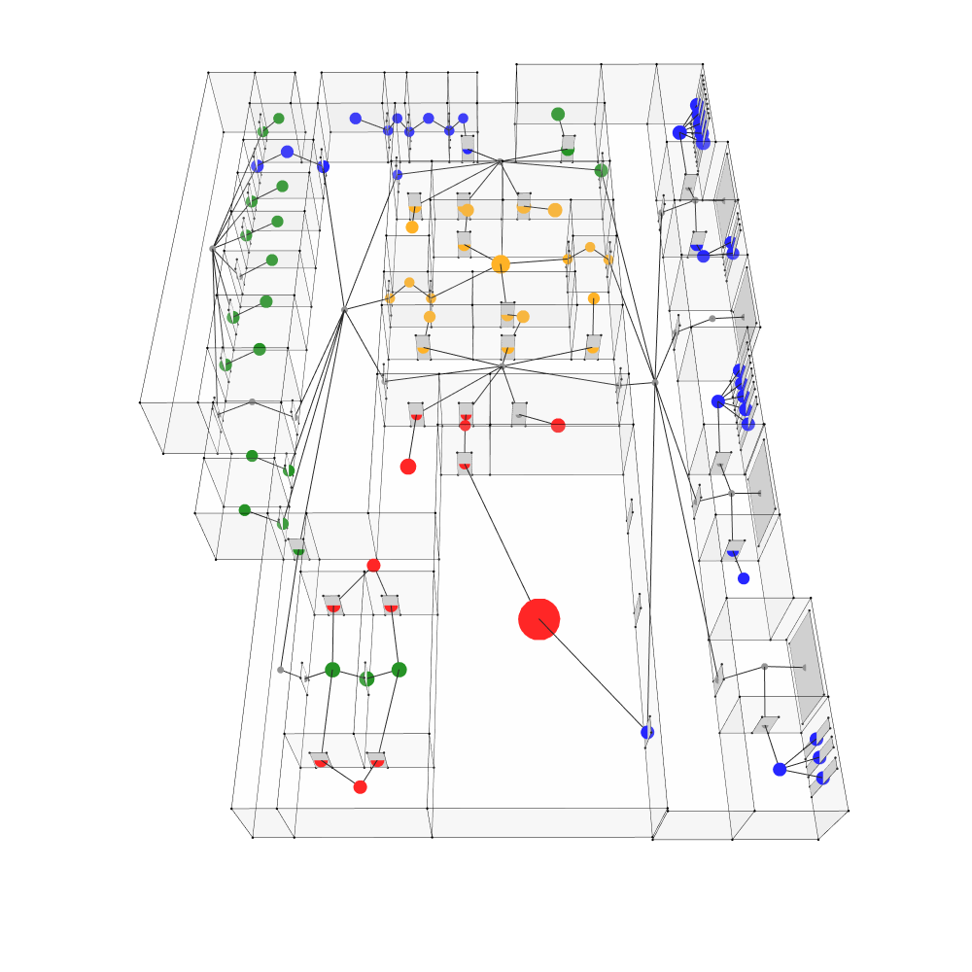
– how architectural elements were mapped to graph components:
Nodes represent each thermal space: hot pools, warm baths, cold rooms, neutral spaces, and corridors. Each node is colored by thermal category and sized proportionally to the room's surface area.
Edges represent two types of relationships. The first is physical through door connection one can move between them. The second is exterior aperture connections; a room has a window opening to the outside, linking the enclosed thermal atmosphere to natural light and the landscape.
– the logic behind node and edge definitions
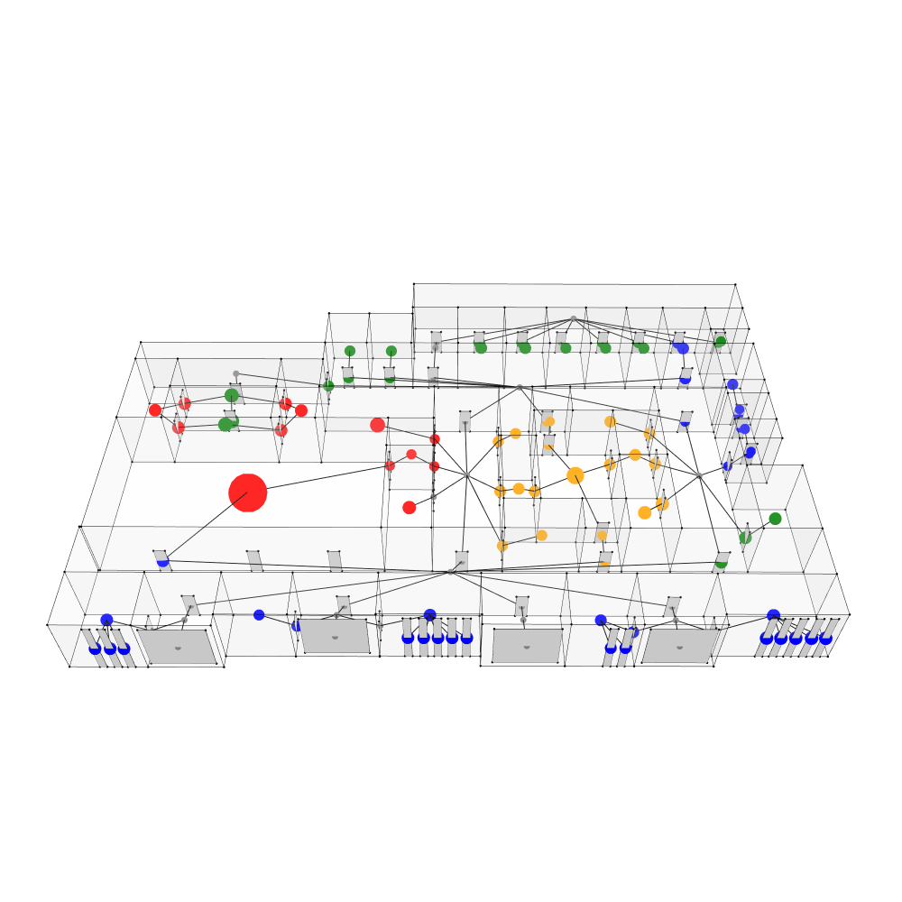
The logic follows Zumthor's design intention: Therme Vals is not a building you navigate freely; it is a choreographed sequence of thermal sensations. By mapping adjacency as edges, the graph reveals which spaces are directly connected and which require passing through intermediate zones. The window connections show which spaces maintain a visual and atmospheric relationship with the exterior, distinguishing inward-focused thermal chambers from those oriented toward the landscape. Together, the graph makes the spatial and thermal logic of the building legible as a network structure.

